Federal, state, and local emergency management experts and other official preparedness organizations all agree that "Drop, Cover, and Hold On" is the appropriate action to reduce injury and death during earthquakes. The ShakeOut is our opportunity to practice how to protect ourselves during earthquakes. This page explains what to do-- and what not to do.
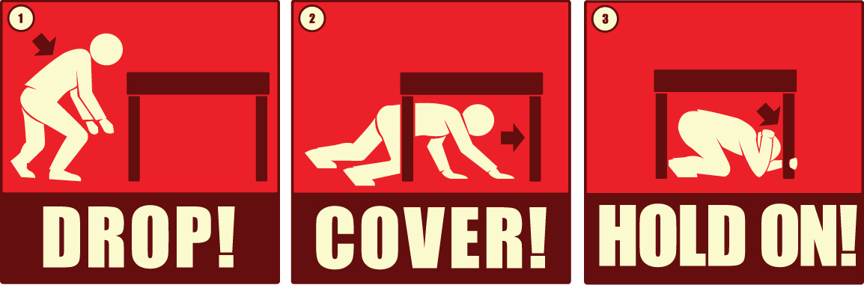
www.dropcoverholdon.org
Learn about Drop, Cover, Hold On from
MySafeLA.org
"ShakeOut Drill Broadcast"
for playing during your ShakeOut drill
audio files are also available
PROTECT YOURSELF. SPREAD THE WORD.
Official rescue teams who have been dispatched to the scene of earthquakes and other disasters around the world continue to advocate use of the internationally recognized "Drop, Cover and Hold On" protocol to protect lives during earthquakes:
- DROP to the ground (before the earthquake drops you!),
- Take COVER by getting under a sturdy desk or table, and
- HOLD ON to it until the shaking stops.
If there isn’t a table or desk near you, drop to the ground in an inside corner of the building and cover your head and neck with your hands and arms. Do not try to run to another room just to get under a table.
These are general guidelines for most situations. Depending on where you are (in bed, driving, in a theater, etc.), you might take other actions, as described in Recommended Earthquake Safety Actions (PDF | RTF).
The main point is to not try to move but to immediately protect yourself as best as possible where you are. Earthquakes occur without any warning and may be so violent that you cannot run or crawl; you therefore will most likely be knocked to the ground where you happen to be. You will never know if the initial jolt will turn out to be start of the big one. You should Drop, Cover, and Hold On immediately!
In addition, studies of injuries and deaths caused by earthquakes in the U.S. over the last several decades indicate that you are much more likely to be injured by falling or flying objects (TVs, lamps, glass, bookcases, etc.) than to die in a collapsed building. Drop, Cover, and Hold On offers the best overall level of protection in most situations.
As with anything, practice makes perfect. To be ready to protect yourself immediately when the ground begins to shake, practice Drop, Cover, and Hold On as children do in school at least once each year.
What NOT to do:
DO NOT get in a doorway! An early earthquake photo is a collapsed adobe home with the door frame as the only standing part. From this came our belief that a doorway is the safest place to be during an earthquake. In modern houses and buildings, doorways are no safer, and they do not protect you from flying or falling objects. Get under a table instead!
DO NOT run outside! Trying to run in an earthquake is dangerous, as the ground is moving and you can easily fall or be injured by debris or glass. Running outside is especially dangerous, as glass, bricks, or other building components may be falling. You are much safer to stay inside and get under a table.
DO NOT believe the so-called "triangle of life"! In recent years, an e-mail has circulated which has recommends potentially life threatening actions, and the source has been discredited by leading experts. Read our special report to learn more.

